Program Introduction

Mission
NWTC offers a trauma-informed environment for sustaining self-worth, nourishing healthy relationships and encouraging the skills required to navigate life’s challenges.

Introduction
Nightwind Treatment Centre (NWTC) serves youth ages 12 to 22. We offer a number of trauma-informed programs to support youth who are experiencing challenges. Through daily living, recreational activities and individual and group counselling, we believe that each youth can acquire the skills necessary to move on and be able achieve to their potential. We work with each individual youth, their caseworker and their family (when appropriate) to develop a plan which will aid them in achieving their individual goals and planning for their future.

All Nightwind Treatment Centre Programs are accredited by the Canadian Accreditation Council and we are proud to be dual licensed as a Residential Facility under the Child, Youth and Family Enhancement Act, and a Residential Addiction Treatment Service under the Mental Health Services Protection Act.

Nightwind Treatment Centre has a contract for service with Child Family Services, North Region. Caseworkers from other Child and Family Services should contact their placement specialist. We also accept referrals from Designated First Nations Agencies (DFNAs) and youth funded through Jordan’s Principle.

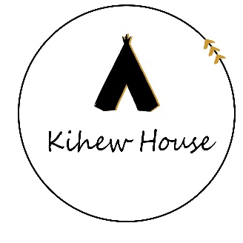
Kihew House, Sturgeon County
- 9-bed, Rural Treatment Program for young women ages 12-18.
- Treatment program supporting abuse history, substance abuse, conflict.
- Indigenous cultural teachings and experiences as the foundation of treatment aligned with the medicine wheel and seven sacred teachings.
- Best fit – Young women ages 14 to 17 with a history of substance use / addiction issues, conflict with family, abuse history, mild to moderate mental health issues such as anxiety, depression, abandonment, attachment, impulsivity, adjustment, unhealthy relationships, poor communication, suicidality. Youth are undecided but open to changing their life are a good fit as we work together to help them see how treatment can support their long-term goals
- Not a good fit – Kihew House is not a lockdown facility. Youth requiring a secure environment, history of physical and sexual violence against other females, youth still under the influence of substances and require medically supervised detox, youth with diagnosed or suspected personality disorders such as Borderline Personality Disorder have difficulty in this group care environment. Kihew is unable to accommodate youth with physical disabilities who cannot navigate stairs.
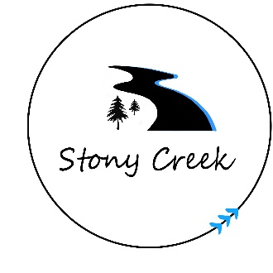
Stony Creek, Tawatinaw Valley
- 7-bed, Rural Co-Ed Treatment Program for youth, young women ages 12-18 and young men ages 12 to 18.
- Treatment program supporting abuse history, substance abuse, conflict.
- Healing and skill-building through agricultural programming.
- Best fit – Young women ages 14 to 17 and young men ages 12 to 14 with a history of substance use / addiction issues, conflict with family, abuse history, mild to moderate mental health issues such as anxiety, depression, abandonment, attachment, impulsivity, adjustment, unhealthy relationships, poor communication, suicidality. Youth who are undecided but open to changing their life are a good fit as we work together to help them see how treatment can support their long-term goals. SC is a good fit for youth who do well with animals and/or like to learn about agriculture and stay busy in a working farm environment. SC is also a supportive environment for youth questioning their sexual identity.
- Not a good fit – SC is not a lockdown facility. Youth requiring a secure environment, history of physical and sexual violence against other males and females, youth still under the influence of substances and require medically supervised detox, youth with diagnosed or suspected personality disorders such as Borderline Personality Disorder have difficulty in this group care environment. SC is unable to accommodate youth with physical disabilities who cannot navigate stairs.
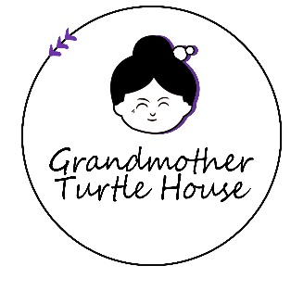
Grandmother Turtle House, Westlock
- 4-bed, Small Town TSIL Program for young women ages 15-22.
- Transition to Semi-Independent Living program for young women who have completed treatment and/or are ready for increased independence.
- Focus on daily living skills, school success, employment and transitioning to independent living.
- Best fit – Young women ages 15 to 22 who gave completed treatment at NWTC or another treatment program, or young women who need a safe place to learn independent living skills in preparation for living on their own. Youth have challenges but also have a repertoire of strategies for managing difficulty.
- Not a good fit – GMT is a TSIL program which provides supervision but safe freedoms for youth. Youth requiring a secure environment, history of physical and sexual violence against other females, youth still under the influence of substances and require medically supervised detox have difficulty in this group care environment.
- With notice, GMT can accommodate youth with a physical disability.
Guiding Principles of NWTC
NWTC is guided by principles of holistic treatment. The principles we use respect both cultural and evidence-based practices that integrate the mental, physical, emotional, and spiritual aspects of the whole self. NWTC guiding principles are:
- Emphasize the distinction of beliefs and traditions;
- Integrate evidence-based practices aligned with trauma-informed care;
- Recognize Indigenous healing practices and cultural as important to developing self-identity, and give clients the opportunity to be exposed to cultural and traditional methods of treatment;
- Effective Treatment requires us to infuse cultural practices, treatment and trauma-informed care into everything we do;
- Respect the individual healing preferences of all clients;
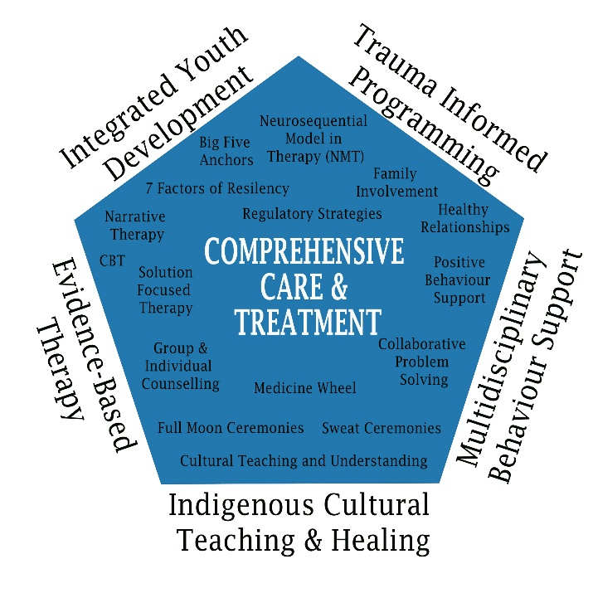
- A systems approach to treatment is carried out with the understanding that a clients’ support network is essential to meaningful and lasting change;
- Teaching and modeling healthy copying strategies and building resiliency to support clients with significant issues including addiction-orientated attitudes and behaviours, and
- The client will graduate from treatment possessing self-determinism, attitudes and skills that can be generalized to their home and community following treatment.

Philosophy
The treatment philosophy of Nightwind Treatment Centre is built on the following:
- Youth self-defeating behaviors can be resolved through the provision of the appropriate assessment, treatment and aftercare services and activities. Youth self-defeating behaviors, if left unresolved, can lead to unhealthy individuals and may contribute to family breakdown.
- In order to achieve health, the treatment program must provide the client with the necessary skills, knowledge, and personal resources to initiate and maintain the recovery process. The treatment activities must assist the client to develop the necessary living and coping skills and healthy alternatives to strengthen and maintain healthy relationships.
- The approach to treatment and the specific activities must be sufficiently flexible to incorporate both current and Traditional healing methods. Indigenous teachings and experiences are seen as an important bridge or stepping stone in helping Indigenous youth to achieve ongoing health.
- The family must be actively involved in the treatment process. In order to facilitate success, every effort must be made to engage family members in the treatment process as well as any pre- and post-treatment activities.
- In order to assist the youth to achieve and maintain a state of recovery, there must be an ongoing focus on aftercare and relapse prevention planning during the active treatment phase. This includes the identification and provision of the appropriate resources and services at the community level.
- Healthy adults who possess the appropriate skills and knowledge will be the best candidates to support youth healing. It is important that youth and their families be provided with the opportunity to interact with other Indigenous individuals and families who are leading healthy lifestyles.
- A comprehensive program reflects the treatment continuum and, in doing so, targets those that have not started, those that have started and those that are chronic in their abuse. The program must be sufficiently flexible to include outreach and treatment services to meet client, family and community needs.
- Building capacity in youth to identify and foster the importance of healthy adults in their lives who serve as “anchors” improves health outcomes. Youth should not be classified as “at-risk”, but rather, thinly or thickly webbed. It is thorough this language we can help youth understand the importance of having adults supports in their life.

Program Staff
Each of our programs have staff trained in trauma-informed care.
- Executive Director – Responsible for all programs and the organization.
- Psychologist Supervisor – Clinical and educational psychologist who supervises the overall treatment program.
- Program Supervisors – Social work trained with youth and supervisory experience. Program supervisors are in direct charge of the program and ensure the safety of all staff and persons-served.
- Therapist – Clinical social worker providing culturally sensitive therapy in an evidence-based manner.
- Youth Success Coach – Specialized training in Non-Violent Crisis Intervention and behaviour support. The Youth Success Coach is responsible for intakes, transitions and positive behaviour support planning for youth.
- Shift Supervisor and/or Keyworker – Responsible for booking appointments, ensuring appropriate documentation completion for youth.
- Youth Care Workers – Frontline staff trained in trauma-informed care. We prioritize staff with Child and Youth Care education and experience. Youth Care Workers support healthy routines and conflict resolution and teach daily living skills for all youth.

Kihew Program Stages of Treatment
Based on therapeutic research for residential care, Aboriginal Healing Foundation found clients in treatment responded well to a healing model combining both cultural and clinical services for Aboriginal people. The healing model focuses on four phases known as STAGES (Spiritual Transformation towards an Awareness and Guidance of Emotional Self) integrates the 7 Traditional Values (Humility, Honesty, Kindness, Caring, Respect, Sharing and Courage. In addition to traditional Indigenous healing and treatment approaches, the program integrates other evidence-based approaches through a focus on trauma-informed care.

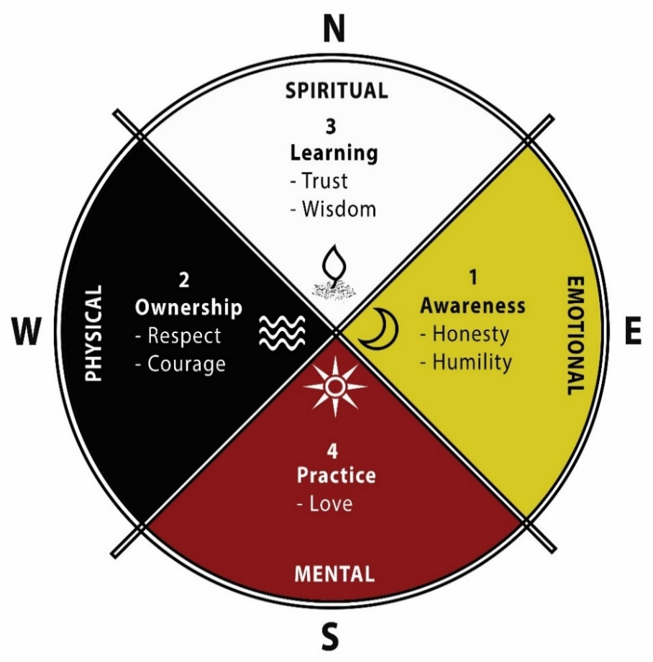
These four stages are useful in learning about oneself, others and clients’ environment. The STAGES of treatment can be done four to six months if clients are receptive, motivated and open to change. These STAGES are interchangeable and can allow for the client to continue to use and apply to all areas of their life after treatment and are continuous. For example, learning new things once they have mastered a concept. Clients are able to reflect on their own progress or treatment duration when using these STAGES.

Youth continue to go through these STAGES each time they learn new things about themselves. This model continues to increase self-awareness that is life-long. In treatment, once a client enters these STAGES, the process becomes easier and quicker. Stages of Grief and Loss are intertwined with the STAGES of Treatment because it allows the client to learn how to grieve/heal from any type of loss and work towards having hope. Loss can include breakdown in family, sexual abuse, death etc.

Stony Creek Stages of Treatment
Stony Creek incorporates a comprehensive approach to individual health and wellness. Comprehensive wellness includes a focus on 10 dimensions which contribute to our overall health. Interventions to health improvement can be resistant when we attempt to improve specific health concerns to the determent of others. Using a systems approach, we focus on a variety of dimensions of health to help youth turn a corner where they have established enough self-help skills and success that they can explore success in other areas of their life.
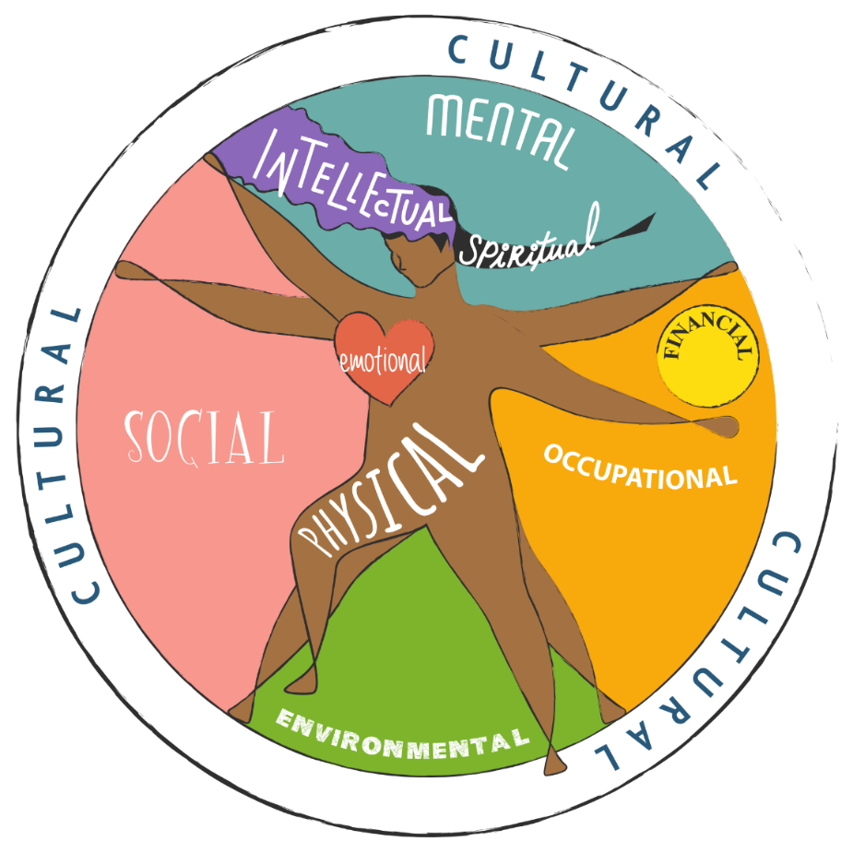
Dimensions of health include areas such as social, emotional, mental, spiritual, cultural, physical, intellectual, financial, occupational and environmental. Treatment Plans are developed which start with a needs assessment of where youth are doing well in specific dimensions of health and where growth is needed. Youth are assessed in preparation for their transition from the program to demonstrate the changes that have occurred with improvements in overall health and wellness.

Thunderbird Landing uses animal based therapeutic activities to develop self-regulation, empathy and responsibility along with on-site individual and group therapy.

Contact Information

Referral Line
780-983-1874
info@nightwind.ca
www.nightwind.ca

Head Office
T.L.C.C Inc. operating as Nightwind Treatment Centre
26130 TWP Road 572
Sturgeon County, AB
T0G 1L1
780-983-1874
ed@nightwind.ca

Kihew House, Sturgeon County
26130 TWP Road 572
Sturgeon County, AB
T0G 1L1
(North East corner of Range Road 262 and Township Road 572 in Sturgeon County)
780-961-3200
programmanager@nightwind.ca

Thunderbird Landing, Tawatinaw Valley
240068 TWP RD 620
Athabasca County, AB
T9S 1R3
(East of Range Road 241A on Township Road 620 in Athabasca County)
780-698-2595
teamleader@nightwind.ca

Grandmother Turtle House, Westlock
10516 102 Street
Westlock, AB
T7P 1K4
780-349-7010
programmanager@nightwind.ca

