Program Introduction

Mission
NWTC offers a trauma informed environment for sustaining self-worth, nourishing healthy relationships and encouraging the skills required to navigate life’s challenges.

Introduction
Nightwind Treatment Centre (NWTC) serves youth ages 12 to 22. We offer a number of trauma-informed programs to support youth who are experiencing challenges. Through daily living, recreational activities and individual and group counselling, we believe that each youth can acquire the skills necessary to move on and be able achieve to their potential. We work with each individual youth, their caseworker and their family (when appropriate) to develop a plan which will aid them in achieving their individual goals and planning for their future.

All Nightwind Treatment Centre Programs are accredited by the Canadian Accreditation Council and we are proud to be dual licensed as a Residential Facility under the Child, Youth and Family Enhancement Act, and a Residential Addiction Treatment Service under the Mental Health Services Protection Act.

Nightwind Treatment Centre has a contract for service with Child Family Services, North Region. Caseworkers from other Child and Family Services should contact their placement specialist. We also accept referrals from Designated First Nations Agencies (DFNAs) and youth funded through Jordan’s Principle.

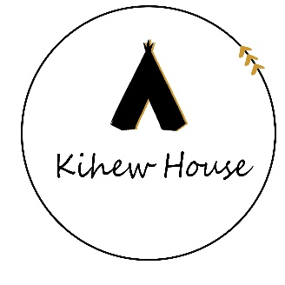
Kihew House, Sturgeon County
- 9-bed, Rural Treatment Program for young women ages 12-18.
- Treatment program supporting abuse history, substance abuse, challenges with resolving conflict with others.
Trauma-informed care integrated into the program.
- Focus on indigenous cultural teachings and experiences as the foundation of our four-stage treatment which is aligned with the medicine wheel and seven sacred teachings.

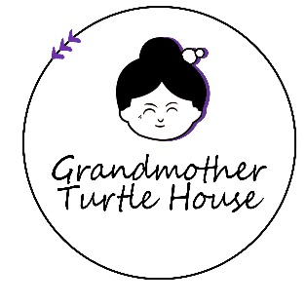
Grandmother Turtle House, Westlock
- 4-bed, TSIL Program for young women ages 15-22.
- Transition to Semi-Independent Living program for stabilized young women who have either completed treatment at NWTC or another treatment program.
- Trauma-informed care integrated into a home-like environment.
- Program focuses on daily living skills, school success, employment and transitioning to independent living.

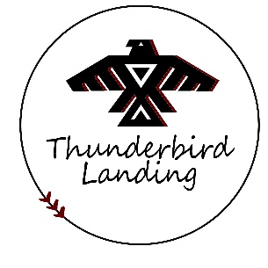
Thunderbird Landing, Tawatinaw Valley
- 7-bed, Rural Co-Ed Receiving Program for youth ages 12-18.
- Receiving program for youth in preparation for treatment; beginning stages of treatment using the medicine wheel healing model and traditional teachings.
- Trauma-informed care integrated into the program, with focus on cultural awareness, regulation, healthy relationship building, developing positive sense of self and conflict resolution skills.
- Focus on healing and skill-building through agricultural programming, connecting with nature, outdoor education, and physical fitness activities.
Guiding Principles of NWTC
NWTC is guided by principles of holistic treatment. The principles we use respect both cultural and evidence-based practices that integrate the mental, physical, emotional, and spiritual aspects of the whole self. NWTC guiding principles are:
- Emphasize the distinction of beliefs and traditions;
- Integrate evidence-based practices aligned with trauma-informed care;
- Recognize Indigenous healing practices and cultural as important to developing self-identity, and give clients the opportunity to be exposed to cultural and traditional methods of treatment;
- Effective Treatment requires us to infuse cultural practices, treatment and trauma-informed care into everything we do;
- Respect the individual healing preferences of all clients;
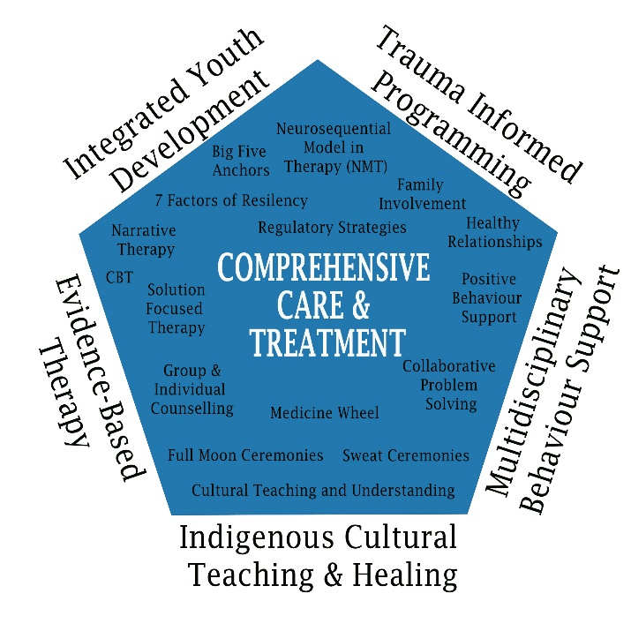
- A systems approach to treatment is carried out with the understanding that a clients’ support network is essential to meaningful and lasting change;
- Teaching and modeling healthy copying strategies and building resiliency to support clients with significant issues including addiction-orientated attitudes and behaviours, and
- The client will graduate from treatment possessing self-determinism, attitudes and skills that can be generalized to their home and community following treatment.

Philosophy
The treatment philosophy of Nightwind Treatment Centre is built on the following:
- Youth self-defeating behaviors can be resolved through the provision of the appropriate assessment, treatment and aftercare services and activities. Youth self-defeating behaviors, if left unresolved, can lead to unhealthy individuals and may contribute to family breakdown.
- In order to achieve health, the treatment program must provide the client with the necessary skills, knowledge, and personal resources to initiate and maintain the recovery process. The treatment activities must assist the client to develop the necessary living and coping skills and healthy alternatives to strengthen and maintain healthy relationships.
- The approach to treatment and the specific activities must be sufficiently flexible to incorporate both current and Traditional healing methods. Indigenous teachings and experiences are seen as an important bridge or stepping stone in helping Indigenous youth to achieve ongoing health.

- The family must be actively involved in the treatment process. In order to facilitate success, every effort must be made to engage family members in the treatment process as well as any pre- and post-treatment activities.
- In order to assist the youth to achieve and maintain a state of recovery, there must be an ongoing focus on aftercare and relapse prevention planning during the active treatment phase. This includes the identification and provision of the appropriate resources and services at the community level.
- Healthy adults who possess the appropriate skills and knowledge will be the best candidates to support youth healing. It is important that youth and their families be provided with the opportunity to interact with other Indigenous individuals and families who are leading healthy lifestyles.
- A comprehensive program reflects the treatment continuum and, in doing so, targets those that have not started, those that have started and those that are chronic in their abuse. The program must be sufficiently flexible to include outreach and treatment services to meet client, family and community needs.
- Building capacity in youth to identify and foster the importance of healthy adults in their lives who serve as “anchors” improves health outcomes. Youth should not be classified as “at-risk”, but rather, thinly or thickly webbed. It is thorough this language we can help youth understand the importance of having adults supports in their life.

Program Staff
Each of our programs have staff trained in trauma-informed care.
- CEO – Clinical and educational psychologist. The CEO supervises the overall treatment program and advises program leadership on best practices.
- Program Supervisors – Social work trained with youth and supervisory experience. Program supervisors are in direct charge of the program and ensure the safety of all staff and persons-served.
- Therapist – Clinical social workers with experience in group care settings. Therapy services are provided to youth as part of the treatment program.
- Youth Success Coach – Specialized training in Non-Violent Crisis Intervention and behaviour support. The Youth Success Coach is responsible for intakes, transitions and positive behaviour support planning for youth.
- Program Attendants – Frontline staff trained in trauma-informed care. We prioritize staff with Child and Youth Care education and experience. Program Attendants support healthy routines and conflict resolution and teach daily living skills for all youth.

Thunderbird Landing Stages of Treatment
We have developed treatment stages inspired by traditional healing and stages of addiction treatment. Thunderbird Landing employs a healing model which focuses on the awareness that improvement is needed; learn about strategies to self-regulate, communicate and resolve conflict; practice skills that have been learned; and finally maintain the skills and strategies necessary to regulate emotions and have healthy relationships.

These four stages are useful in learning about oneself, others and an awareness of the environment and how our actions impact others. Treatment can be completed in four to six months if clients are receptive, motivated and open to change. These stages are interchangeable and can allow for the client to continue to use and apply to all areas of their life after treatment and are continuous. Clients are able to reflect on their own progress or treatment duration when using these stages of treatment.
Thunderbird Landing uses agricultural learning and experience to provide a regulatory environment and as away of teaching responsibility and practical skills for fostering independence. We use a trauma-informed care milieu to support the development of healthy relationships and regulatory strategies that are aligned with the six core strengths of trauma informed care which include attachment, self-regulation, affiliation, attunement, tolerance and respect. These six core strengths from the Child Trauma Academy help inform the treatment work and environment we create to promote healing.

Kihew Program Stages of Treatment
Based on therapeutic research for residential care, Aboriginal Healing Foundation found clients in treatment responded well to a healing model combining both cultural and clinical services for Aboriginal people. NWTCs healing model focuses on four phases known as STAGES (Spiritual Transformation towards an Awareness and Guidance of Emotional Self) integrates the 7 Traditional Values (Humility, Honesty, Kindness, Caring, Respect, Sharing and Courage. In addition to traditional Indigenous healing and treatment approaches, NWTC integrates other evidence-based approaches through a focus on trauma-informed care.

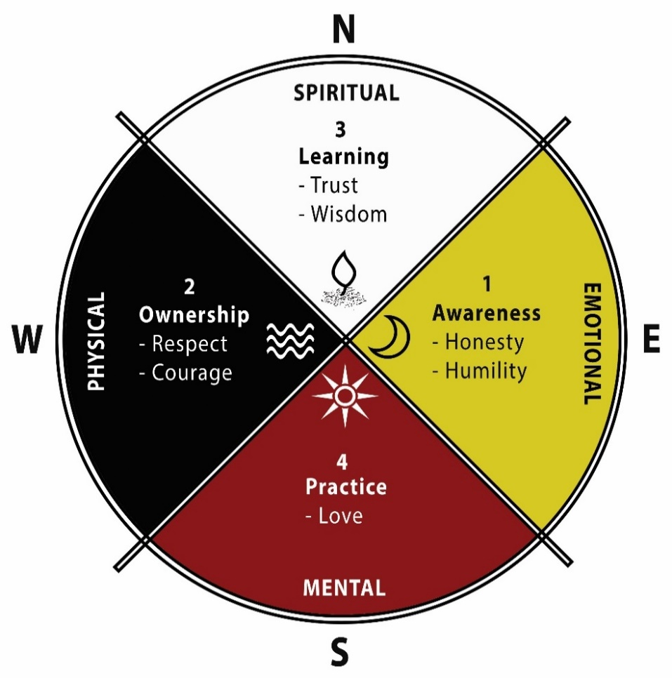
These four stages are useful in learning about oneself, others and clients’ environment. The STAGES of treatment can be done four to six months if clients are receptive, motivated and open to change. These STAGES are interchangeable and can allow for the client to continue to use and apply to all areas of their life after treatment and are continuous. For example, learning new things once they have mastered a concept. Clients are able to reflect on their own progress or treatment duration when using these STAGES.

Clients continue to go through these STAGES each time they learn new things about themselves. This model continues to increase self-awareness that is life-long. In treatment, once a client enters these STAGES, the process becomes easier and quicker. Stages of Grief and Loss are intertwined with the STAGES of Treatment because it allows the client to learn how to grieve/heal from any type of loss and work towards having hope. Loss can include breakdown in family, sexual abuse, death etc.

Contact Information

Referral Line
780-983-1874
info@nightwind.ca
www.nightwind.ca

Head Office
T.L.C.C Inc. operating as Nightwind Treatment Centre
26130 TWP Road 572
Sturgeon County, AB
T0G 1L1
780-237-6283
ceo@nightwind.ca

Kihew House, Sturgeon County
26130 TWP Road 572
Sturgeon County, AB
T0G 1L1
(North East corner of Range Road 262 and Township Road 572 in Sturgeon County)
780-961-3200
programmanager@nightwind.ca

Thunderbird Landing, Tawatinaw Valley
240068 TWP RD 620
Athabasca County, AB
T9S 1R3
(East of Range Road 241A on Township Road 620 in Athabasca County)
780-698-2595
teamleader@nightwind.ca

Grandmother Turtle House, Westlock
10516 102 Street
Westlock, AB
T7P 1K4
780-349-7010
programmanager@nightwind.ca

